5. Use the Porter Stemmer algorithm to perform word stemming on a list of words using python
libraries.
Aim: To perform word stemming using the Porter Stemmer algorithm in Python.
Procedure:
- Install NLTK.
- Import PorterStemmer.
- Create a stemmer object.
- Apply stemming to a list of words.
- Display the original words and stems.
Code:
from nltk.stem import PorterStemmer
ps = PorterStemmer()
words = ["playing", "played", "plays", "studies", "running"]
for word in words:
print(word, "->", ps.stem(word))
Output:
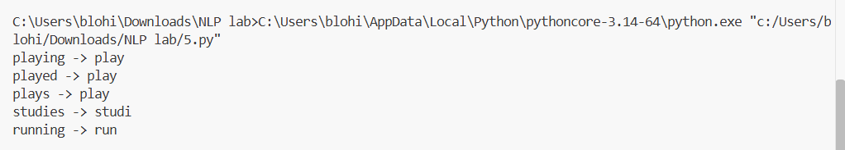
Result: The Porter Stemmer algorithm successfully reduced words to their stems.

